The truth table below has one column that’s not filled in with true/false values.

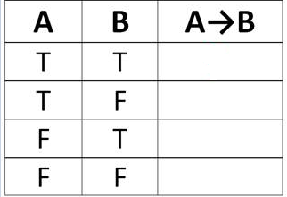

What should go in the first box? **True**

What should go in the second box? **False**

What should go in the third box? **True**

What should go in the fourth box? **True**

Which of the following is the correct parenthesized version of the expression

P ∧ ¬ Q ∧ R → ¬ S ∧ T? **(((P ∧ ( ¬ Q)) ∧ R) → ((¬ S) ∧ T))**

Is (T → ¬W) ∧ X a WFF? **Yes**

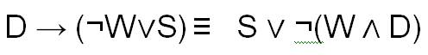

The following is the partially written proof that

However, the reasons have not been filled in.

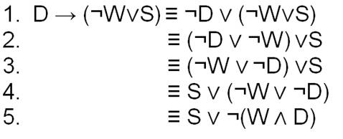

What reason should be written at the end of line 1? **Conv1**

What reason should be written at the end of line 2? **Assoc**

What reason should be written at the end of line 3? **Comm**

What reason should be written at the end of line 4? **Comm**

What reason should be written at the end of line 5? **DeM1**